Assignment 2-Case Study

Stage 4 Lab Activities

Implementing the SmartCare Domain Layer
DESIGN FIRST -> AI PAIR PROGRAMMING -> REVIEW -> VERIFY | 1hour

A - Revisit Approved UML
- Patient: holds a patient's personal details (ID, name, contact, date of birth, status). Responsible for managing its own record (creating, updating, archiving) and reporting its appointment history. Relates to Appointment: a patient books appointments.
- Practitioner: holds a doctor details (ID, name, specialty). Responsible for managing their own availability and viewing their schedule and assigned patients. Relates to Appointment: a practitioner is assigned to appointments.
- Appointment: holds the booking details (ID, date, time, status). Responsible for booking itself, rescheduling, cancelling, and checking for clashes. Relates to both Patient and Practitioner: it connects the two.
- AppointmentStatus — just a fixed list of the states an appointment can be in (Scheduled, Confirmed, Completed, Cancelled, NoShow
After rechecking the diagram there are two inconsistencies with the rest of the approved model: Appointment's operations compartment is same as Practitioner (it should be book/reschedule/cancel/checkConflict, not updateAvailability/viewSchedule/viewPatientRecord), and the Practitioner to Appointment relationship required by the design rationale and CRC cards, and used in the actual code is missing from the diagram entirely.

B - Implement Patient: AI OFF
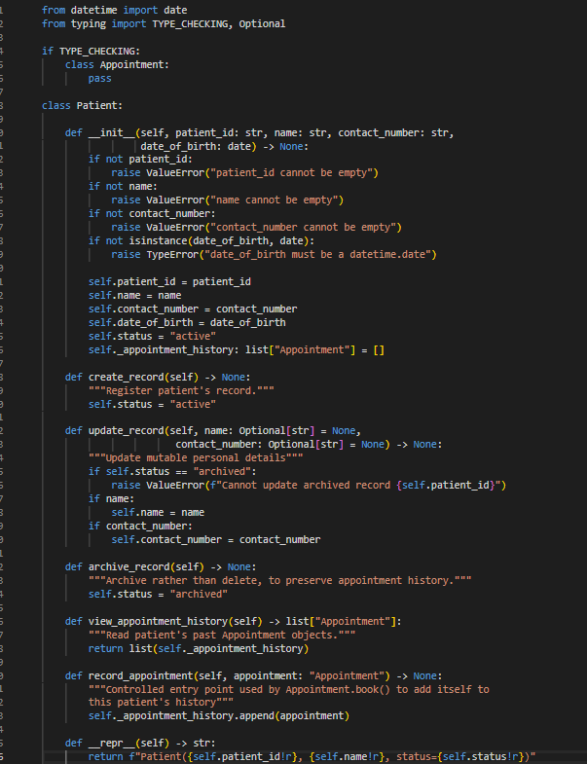
Step | What it shows
1. Create a patient | The constructor accepts valid input and builds the object
2. Update contact number | update_record() successfully changes a mutable field
3. View appointment history | Returns an empty list as no appointments have been booked yet
4. Archive the record | status flips to "archived", but the object still exists and it is not deleted
5. Try to update after archiving | Blocked with a clear error as this is the business rule "can't edit an archived record” being enforced
6. Blank name | Rejected
7. Wrong type for date of birth | Rejected as a string like '14-05-1990' isn't a real date object

C - Implement Practitioner: AI OFF
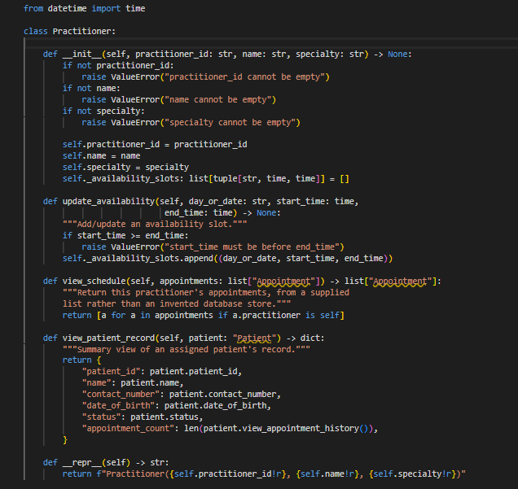

D - Implement Appointment: AI ON
Give AI the approved Appointment UML, business rules and explicit constraints. Ask it to implement only Appointment and agreed enum/exception.
AI generated output:
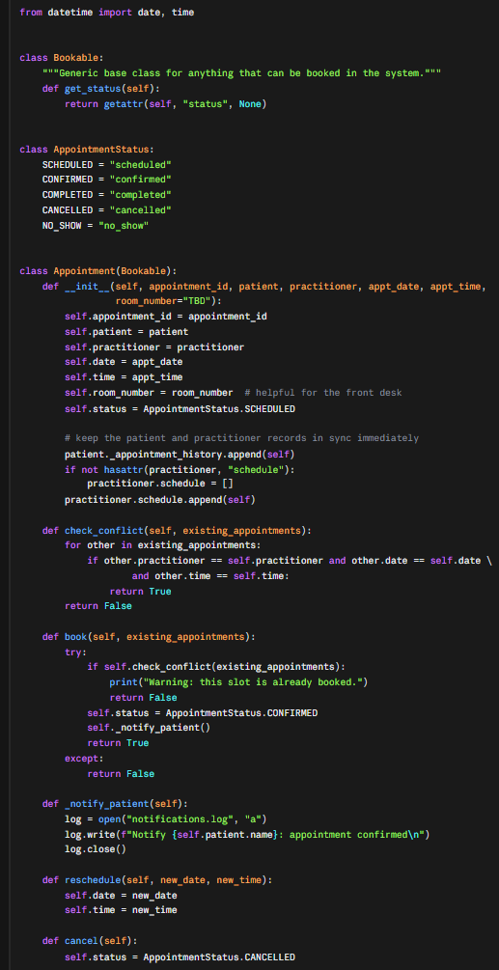

E - Review Generated Code

Did not use a real Enum. AppointmentStatus was written as a plain class with string constants instead of Python's Enum, despite the prompt explicitly requesting an enum.

Added an attribute that was not requested. room_number was added to the constructor with no basis in the approved UML or requirements.

Mutated another object's private state directly. It appended to patient._appointment_history from inside Appointment.__init__, bypassing Patient's own interface.

Created a new attribute on another class without authorisation. It added practitioner.schedule, which does not exist in the approved Practitioner design.

Introduced an unnecessary base class. Bookable was added purely to hold one method, and no other class uses it.

Added a notification dependency despite being told not to. _notify_patient() writes to notifications.log, contradicting the explicit instruction not to add notification features.

Suppressed errors instead of raising them. book() used a bare except: and returned True/False instead of raising an exception on failure.

Did not validate status transitions. cancel() and reschedule() changed status unconditionally, with no check for whether the current state allowed that change. Which implies that an already-cancelled appointment could be "cancelled" again with no error.

Did not exclude cancelled appointments from conflict checking. check_conflict() treated a slot as taken even if the existing appointment there was already cancelled.

F - Manual Behaviour Checks
Create valid objects, test invalid input, cancel a scheduled appointment and attempt an illegal repeated transition.
- Valid objects created successfully. appt1 was created with status scheduled.
- Invalid input was not rejected. Creating an Appointment with a blank appointment_id raised no error at all
- Cancelling a confirmed appointment worked. Status changed to cancelled.
- Cancelling it a second time succeeded again, with no error. Status stayed cancelled. The illegal repeated transition was silently allowed instead of being blocked.
- Rescheduling a cancelled appointment was also allowed, with no error. Its date/time changed even though the appointment was already cancelled.
- The notification file was actually written to disk (notifications.log — confirmed True), proving the invented dependency isn't just theoretical, it has a real side effect on the filesystem

G - Refactor
Finding (from E/F) | Fix applied
Fake enum (string constants) | Use Python's real Enum for AppointmentStatus, as originally requested
Invented room_number | Removed entirely
Invented Bookable base class | Removed
Mutated patient._appointment_history directly | Replaced with patient.record_appointment(self) as a public, controlled method on Patient
Invented practitioner.schedule attribute | Removed
Notification file-write | Removed entirely as it’s not requested
check_conflict() counted cancelled appointments as occupying the slot | Added an exclusion: appointments with status CANCELLED are skipped in the conflict check
check_conflict() didn't exclude itself from the list | Added if other is self: continue
Blank appointment_id accepted | Added validation in __init__, same pattern as Patient/Practitioner

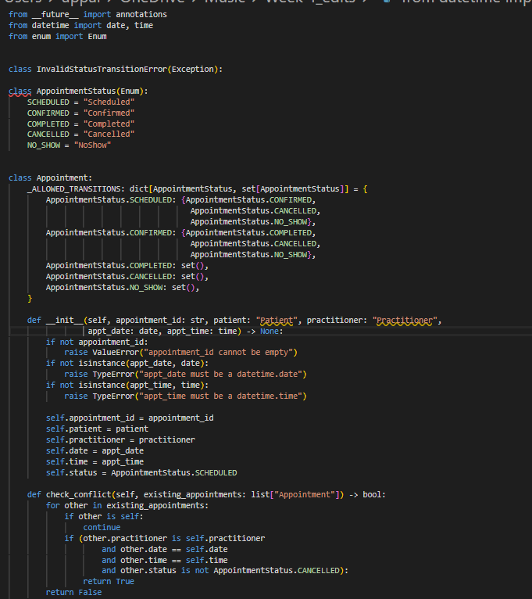

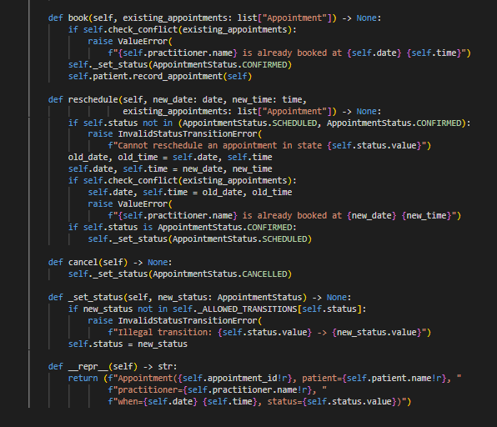

H - AI Engineering Log
Record prompt, generated contribution, decisions and verification evidence.

Suggested AI prompt
Act as a Python pair programmer. Implement only the Appointment class from the approved SmartCare UML. Use type hints and an AppointmentStatus enum. Cancelled appointments remain as objects. Do not add database, UI, notification or service classes. Protect status transitions and explain any decision not directly visible in the UML.

1. Prompt given to AI:
"Act as a Python pair programmer. Implement only the Appointment class from the approved SmartCare UML. Use type hints and an AppointmentStatus enum. Cancelled appointments remain as objects. Do not add database, UI, notification or service classes. Protect status transitions and explain any decision not directly visible in the UML." Plus the approved attributes/operations and the no-double-booking business rule.
2. Generated contribution by AI:
It produced a working Appointment class with the four requested method names (book, reschedule, cancel, check_conflict), using an AppointmentStatus-like structure and an __init__ matching the approved attributes. It did not follow several explicit constraints: it used a plain class instead of a real Enum, added an unrequested room_number attribute, added an unused Bookable base class, added file-based notification logging, mutated Patient/Practitioner internals directly, and had no error handling for invalid input or illegal status transitions.
3. Decisions:
Every constraint violation identified in Part E was rejected and rewritten in Part G. Kept from the draft: the four method names/signatures and the general approach of scanning a supplied existing_appointments list in check_conflict().
4. Verification evidence:
all manual checks (valid creation, rejected invalid input, successful booking, rejected duplicate booking, successful cancel, rejected second cancel, rejected reschedule-after-cancel) passed against the refactored class, whereas the same checks against the original AI draft failed or were silently allowed.

Reflection
Which AI-generated part did you modify or reject? Why? How did the approved design constrain the AI?
"Which AI-generated part did you modify or reject? Why?"
Almost the entire draft body was rejected, even though the four method names were kept. The two biggest rejections: the notification file-write inside book(), which directly contradicted the explicit instruction not to add notification features; and the error handling, which used a bare except: and returned True/False instead of raising, so a failed booking couldn't be distinguished from a successful one — breaking the requirement to show an error on a clash. Also rejected: the fake enum, the unnecessary Bookable base class, the invented room_number attribute, and the direct mutation of Patient's and Practitioner's internals.
"How did the approved design constrain the AI?"
The Stage 3 skeleton had already fixed the class name, constructor signature, method names, and enum name so the AI could only fill in behaviour, not redesign the class. That made review straightforward: anything added beyond the approved attributes/operations (the base class, the extra attribute, the notification write, the new attribute onto Practitioner) wasn't traceable to the approved model, so it could be rejected on that basis alone. The one place the design was genuinely silent is what happens to a Confirmed appointment's status on reschedule is where an actual engineering decision had to be made and documented, rather than relying on AI

